**Day 1: 5/14/2025**

**User Id : tdyeswan**

**Name: Yewanth T**

**SDLC:**

**Task 1:**

**What is SDLC?**

SDLC stands for Software Development Life Cycle, a structured process used by development teams to build and maintain software efficiently. It provides a framework for planning, designing, developing, testing, deploying, and maintaining software, ensuring a systematic and consistent approach to software development.

**Task 2:**

**Why is SDLC?**

SDLC is needed because:

1. SDLC is needed to keep a track on project.
2. To collaborate with other teams and work.
3. To identify and overcome errors in prior and ensure quality.
4. Customer Satisfaction.
5. Since, different projects needs different approaches in SDLC there are plenty of models like waterfall, RAD modes, Spiral model, V-model etc. we can adapt different model approaches based on the requirement of the project.

**Task 3:**

**What are the stages of SDLC?**

The stages involved in SDLC are:

1. Requirement Gathering.
2. Planning.
3. Designing.
4. Development.
5. Testing.
6. Maintenance.

**Task 4:**

**SDLC models:**

[1. Agile Model](https://www.geeksforgeeks.org/top-8-software-development-models-used-in-industry/#1-agile-model)

[2. Waterfall Model](https://www.geeksforgeeks.org/top-8-software-development-models-used-in-industry/#2-waterfall-model)

[3. V-Model](https://www.geeksforgeeks.org/top-8-software-development-models-used-in-industry/#3-vmodel)

[4. Incremental Model](https://www.geeksforgeeks.org/top-8-software-development-models-used-in-industry/#4-incremental-model)

[5. RAD Model](https://www.geeksforgeeks.org/top-8-software-development-models-used-in-industry/#5-rad-model)

[6. Iterative Model](https://www.geeksforgeeks.org/top-8-software-development-models-used-in-industry/#6-iterative-model)

[7. Spiral Model](https://www.geeksforgeeks.org/top-8-software-development-models-used-in-industry/#7-spiral-model)

[8. Prototype model](https://www.geeksforgeeks.org/top-8-software-development-models-used-in-industry/#8-prototype-model)

## **1. Agile Model**

[Agile Development Model](https://www.geeksforgeeks.org/software-engineering-agile-development-models/) is a combination of iterative and incremental models, that is, it is made up of iterative and incremental models.

The Agile Model was created mainly to make changes in the middle of software development so that the software project can be completed quickly.

* In the agile model, the software product is divided into small incremental parts. In this, the smallest part is developed first and then the larger one.
* And each incremental part is developed over iteration.
* Each iteration is kept small so that it can be easily managed. And it can be completed in two-three weeks. Only one iteration is planned, developed and deployed at a time.

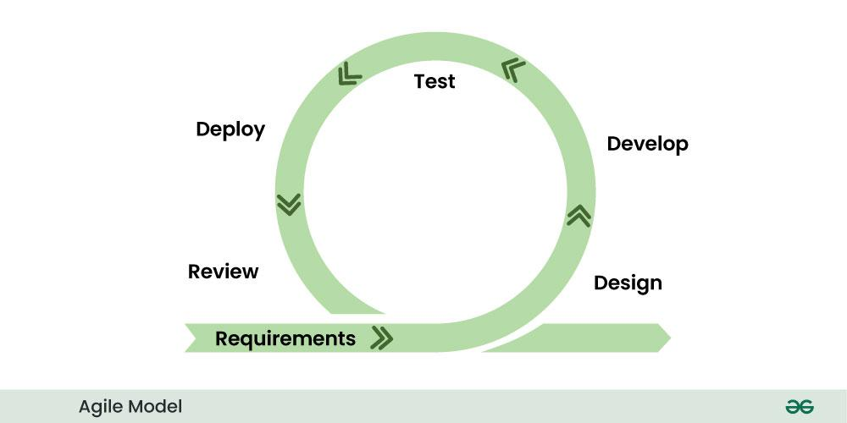

## **2. Waterfall Model**

[Waterfall Model](https://www.geeksforgeeks.org/waterfall-model/) is a famous and good version of [SDLC(System Development Life Cycle)](https://www.geeksforgeeks.org/software-development/) for software engineering. The waterfall model is a linear and sequential model, which means that a development phase cannot begin until the previous phase is completed. We cannot overlap phases in waterfall model.

### **Phases of Waterfall model**

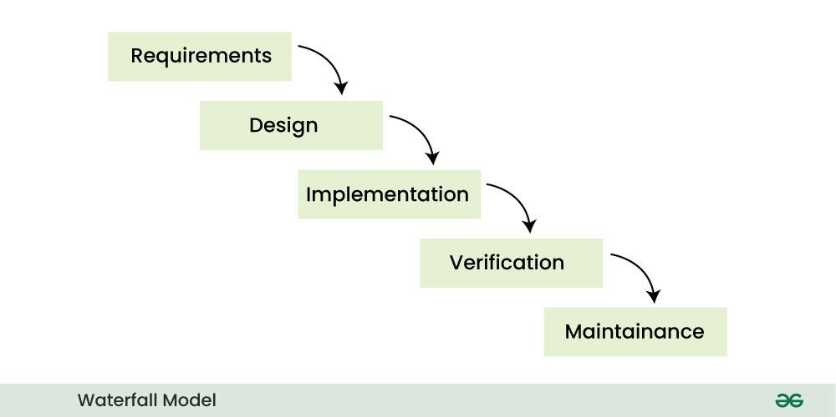Waterfall Model

Similarly waterfall model also works, once one phase of development is completed then we move to the next phase but cannot go back to the previous phase. In the waterfall model, the output of one phase serves as the input for the other phase.

## **3. V-Model**

[V-Model](https://www.geeksforgeeks.org/software-engineering-sdlc-v-model/) is an SDLC model, it is also called Verification and Validation Model. V-Model is widely used in the Software Development Process, and it is considered a disciplined model. In V-Model, the execution of each process is sequential, that is, the new phase starts only after the previous phase ends.

### **Phases of V-model**

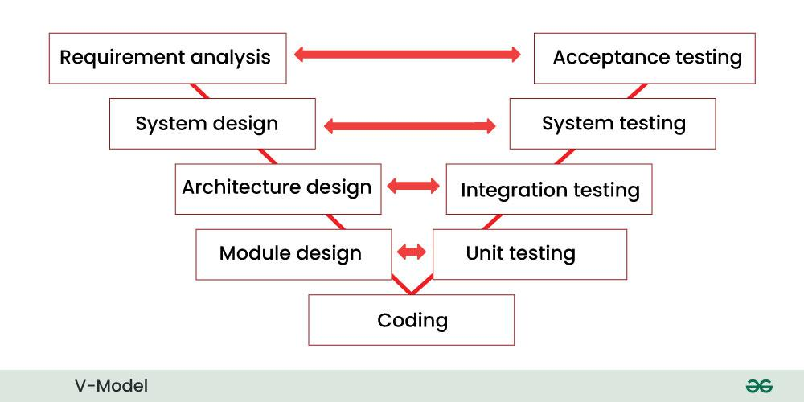

## **4. Incremental Model**

In [Incremental Model](https://www.geeksforgeeks.org/software-engineering-incremental-process-model/), the Software Development Process is divided into several increments and the same phases are followed in each increment. In simple language, under this model a complex project is developed in many modules or builds.

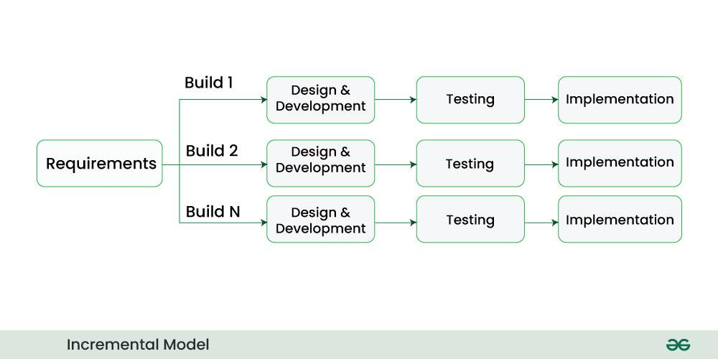Incremental Model

## **5. RAD Model**

[RAD Model](https://www.geeksforgeeks.org/software-engineering-rapid-application-development-model-rad/) stands for rapid application development model. The methodology of RAD model is similar to that of incremental or waterfall model. It is used for small projects.

The main objective of RAD model is to reuse code, components, tools, processes in project development.

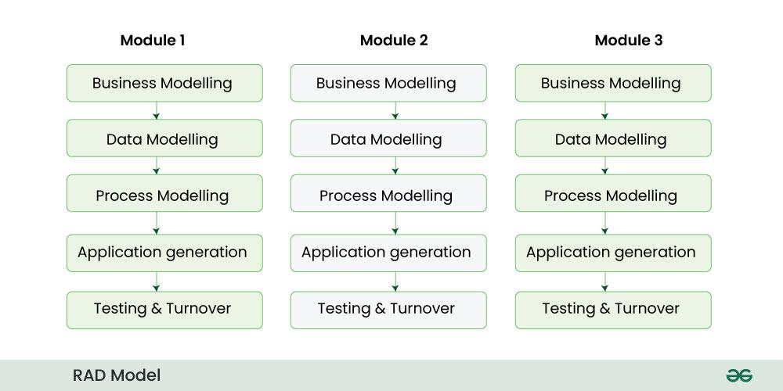RAD Model

## **6. Iterative Model**

In [Iterative Model](https://www.geeksforgeeks.org/software-engineering-iterative-waterfall-model/) we start developing the software with some requirements and when it is developed, it is reviewed. If there are requirements for changes in it, then we develop a new version of the software based on those requirements. This process repeats itself many times until we get our final product.

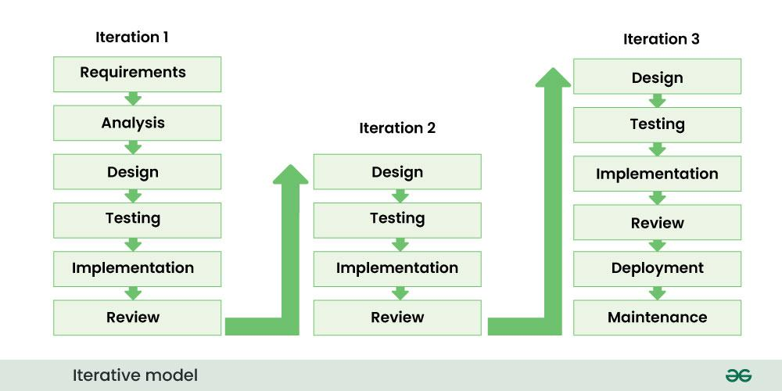Iterative Model

* So, in Iterative model a software is developed by following several iterations. Iteration means that we are repeating the Development Process again and again. For example, we develop the first version of the software following the SDLC process with some software requirements.

## **7. Spiral Model**

[Spiral Model](https://www.geeksforgeeks.org/software-engineering-spiral-model/) is a software development process model. This model has characteristics of both iterative and waterfall models. This model is used in projects which are large and complex. This model was named spiral because if we look at its figure, it looks like a spiral, in which a long curved line starts from the center point and makes many loops around it. The number of loops in the spiral is not decided in advance but it depends on the size of the project and the changing requirements of the user. We also call each loop of the spiral a phase of the software development process.

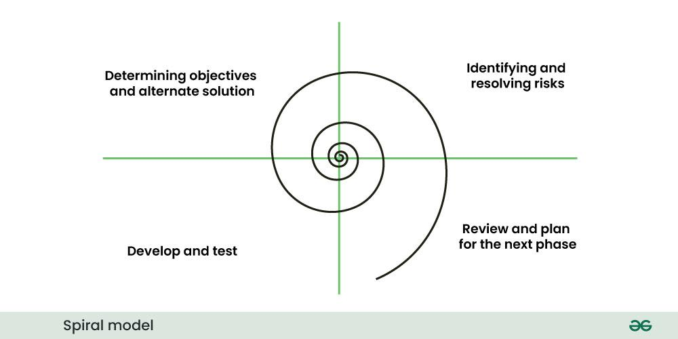Spiral Model

In Spiral Model the entire process of software development is described in four phases which are repeated until the project is completed.

## **8. Prototype model**

[Prototype Model](https://www.geeksforgeeks.org/software-engineering-prototyping-model/) is an activity in which prototypes of software applications are created. First a prototype is created and then the final product is manufactured based on that prototype.One problem in this model is that if the end users are not satisfied with the prototype model, then a new prototype model is created again, due to which this model consumes a lot of money and time.

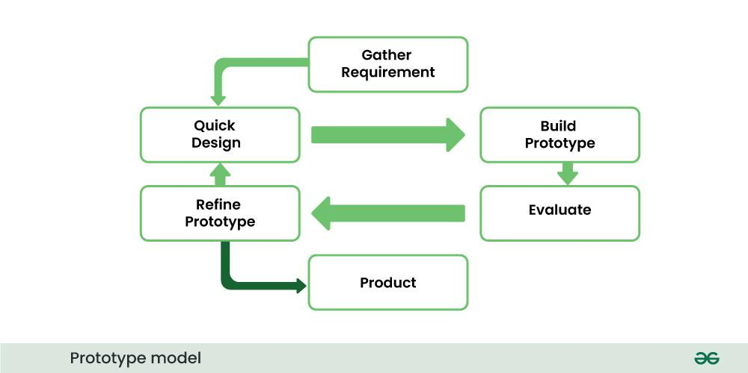Prototype Model

* The prototype model was developed to overcome the shortcomings of the waterfall model.
* This model is created when we do not know the requirements well.
* The specialty of this model is that this model can be used with other models as well as alone.

**Task 5:**

**What are different networking types?**

The four main types of networks, categorized by size and scope, are:

1. Personal Area Network (PAN)
2. Local Area Network (LAN)
3. Metropolitan Area Network (MAN)
4. Wide Area Network (WAN)

**Task 6:**

**What are the types of servers?**

In networking, servers are categorized by the specific services they provide, including web servers, mail servers, file servers, and application servers, among others. Rack, blade, and tower servers are also differentiated based on their physical design and deployment.

Here's a more detailed look at some key server types:

1. Web Servers: These servers host and deliver websites, web applications, and other web-based content. Examples include Apache and Nginx.

2. Mail Servers: These servers handle the sending, receiving, and storage of email messages.

3. File Servers: File servers provide centralized storage and access to files and folders for users on a network.

4. Print Servers: These servers manage and route print requests from clients to printers on the network.

5. Application Servers: These servers host and run software applications, allowing users to access them without installing them locally.

6. Database Servers: These servers manage and store databases, allowing various applications to access and manipulate data.

7. Cloud Servers: These are virtual servers hosted in a cloud computing environment, offering scalable and flexible computing resources.

8. Proxy Servers: Proxy servers act as intermediaries between clients and other servers, filtering requests and providing security features.

9. Domain Name System (DNS) Servers: DNS servers translate domain names (like www.google.com) into IP addresses, enabling users to find web resources.

10. Dynamic Host Configuration Protocol (DHCP) Servers: DHCP servers automatically assign IP addresses to devices on a network, making it easier to manage and configure devices.

11. Rack Servers: These servers are designed to fit into standard server racks, providing space-saving solutions for high-density deployments.

12. Blade Servers: Blade servers are modular, compact servers that can be inserted into a blade enclosure, enabling efficient use of space and power.

13. Tower Servers: Tower servers are traditional desktop-style servers, offering a more versatile and customizable approach to server deployments.

**Task 7: (Verbal Task)**

What do you know about DNS? Domain Name Server

**Task 8:**

**what is TCP and UDP? What is the difference?**

TCP and UDP are two different protocols used to transmit data over networks, both operating within the transport layer of the TCP/IP model. TCP (Transmission Control Protocol) is a reliable, connection-oriented protocol, while UDP (User Datagram Protocol) is a less reliable, connectionless protocol

| Feature | TCP | UDP |
| --- | --- | --- |
| Reliability | Reliable | Unreliable |
| Connection | Connection-Oriented | Connectionless |
| Flow Control | Yes | No |
| Overhead | More overhead | Less overhead |
| Speed | Slower (due to reliability mechanisms) | Faster (due to lack of reliability) |
| Examples | Web browsing, email, file transfer | Online gaming, streaming, DNS lookups |

**Task 9:**

**What do you know about mac address ? What is the difference between Mac address and IP address.**

A MAC (Media Access Control) address is a unique identifier assigned to a network interface controller (NIC) by the manufacturer, acting as the device's physical address on a local network. An IP (Internet Protocol) address, on the other hand, is a logical address used for communication across networks and the internet, assigned by a network administrator or ISP

* **Purpose:** MAC addresses identify a device on a local network, while IP addresses identify a device across networks and the internet.
* **Address Type:** MAC addresses are hardware addresses (physical), while IP addresses are software addresses (logical).
* **Location:** MAC addresses are used on the local network (LAN), while IP addresses are used across networks and the internet.
* **Assigning Authority:** MAC addresses are assigned by the manufacturer and are generally permanent, while IP addresses are assigned by a network administrator or ISP and can be dynamic.
* **Layer of Implementation:** MAC addresses operate at the data link layer (Layer 2) of the OSI model, while IP addresses operate at the network layer (Layer 3).

**Task 10:**

**What is OSI model?**

The Open Systems Interconnection (OSI) model describes seven layers that computer systems use to communicate over a network. The OSI model is divided into seven distinct layers, each with specific responsibilities, ranging from physical hardware connections to high-level application interactions.

## **Layers of the OSI Model**

There are 7 layers in the OSI Model and each layer has its specific role in handling data. All the layers are mentioned below:

* [Physical Layer](https://www.geeksforgeeks.org/physical-layer-in-osi-model)
* [Data Link Layer](https://www.geeksforgeeks.org/data-link-layer)
* [Network Layer](https://www.geeksforgeeks.org/network-layer-in-osi-model/)
* [Transport Layer](https://www.geeksforgeeks.org/transport-layer-in-osi-model/)
* [Session Layer](https://www.geeksforgeeks.org/session-layer-in-osi-model)
* [Presentation Layer](https://www.geeksforgeeks.org/presentation-layer-in-osi-model)
* [Application Layer](https://www.geeksforgeeks.org/application-layer-in-osi-model)

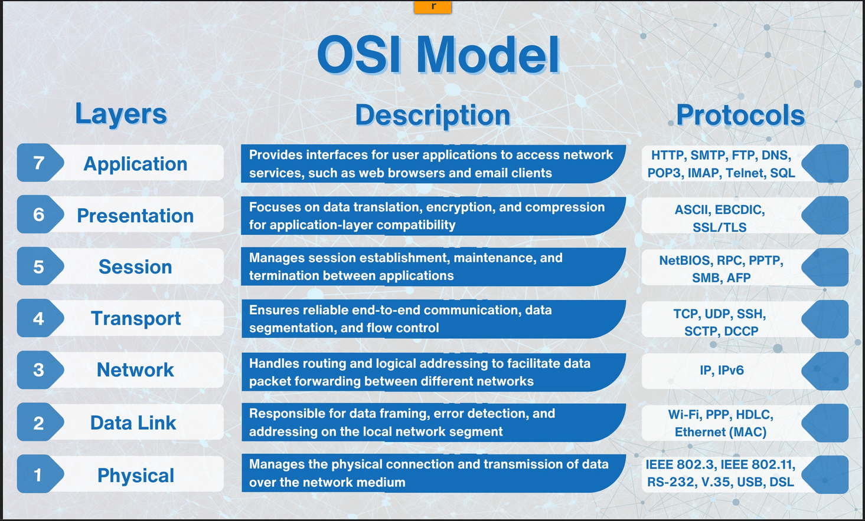

### **1. Physical Layer**

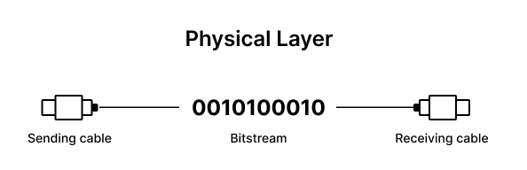

The Physical Layer is responsible for the physical connection between devices. It defines the hardware elements involved in the network, including cables, switches, and other physical components. This layer also specifies the electrical, optical, and radio characteristics of the network.

Functions of the Physical Layer include the modulation, bit synchronization, and transmission of raw binary data over the physical medium. Technologies such as Fiber Optics and Wi-Fi operate at this layer, ensuring that the data physically moves from one device to another in the network.

### **2. Data Link Layer**

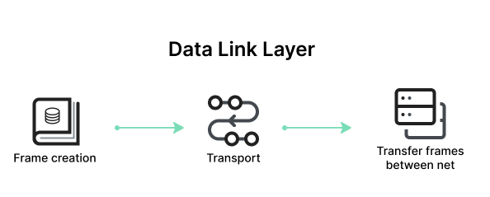

The Data Link Layer is responsible for node-to-node data transfer and error detection and correction. It ensures that data is transmitted to the correct device on a local network segment. This layer manages [MAC (Media Access Control)](https://www.imperva.com/learn/application-security/broken-object-level-authorization-bola/) addresses and is divided into two sublayers: Logical Link Control (LLC) and Media Access Control (MAC).

Protocols and technologies at this layer include Ethernet, which defines the rules for data transmission over local area networks (LANs), and Point-to-Point Protocol (PPP) for direct connections between two network nodes. It also includes mechanisms for detecting and possibly correcting errors that may occur in the Physical Layer.

### **3. Network Layer**

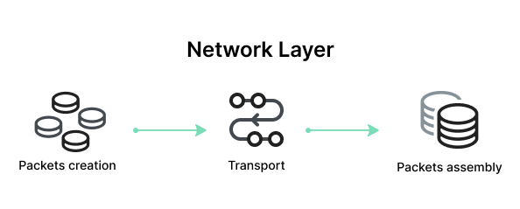

The Network Layer is responsible for data routing, forwarding, and addressing. It determines the best physical path for data to reach its destination based on network conditions, the priority of service, and other factors. This layer manages logical addressing through IP addresses and handles packet forwarding.

Key protocols at this layer include the Internet Protocol (IP), which is important for routing and addressing, Internet Control Message Protocol (ICMP) for diagnostic and error-reporting purposes, and routing protocols like Routing Information Protocol (RIP) that manage the routing of data across networks.

### **4. Transport Layer**

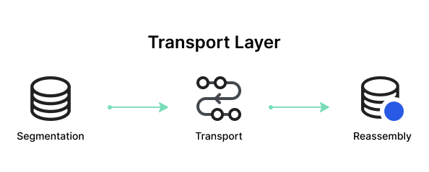

The Transport Layer provides end-to-end communication services for applications. It ensures complete data transfer, error recovery, and flow control between hosts. This layer segments and reassembles data for efficient transmission and provides reliability with error detection and correction mechanisms.

Protocols at this layer include [Transmission Control Protocol](https://www.imperva.com/learn/ddos/tcp-transmission-control-protocol/) (TCP) and [User Datagram Protocol](https://www.imperva.com/learn/ddos/udp-user-datagram-protocol/) (UDP). TCP is connection-oriented and ensures reliable data transfer with error checking and flow control, making it suitable for applications like web browsing and email. UDP is connectionless, offering faster, though less reliable, transmission, suitable for applications like video streaming and online gaming.

### **5. Session Layer**

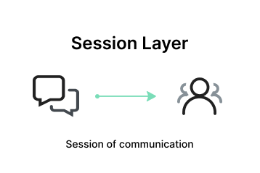

The Session Layer manages and controls the connections between computers. It establishes, maintains, and terminates connections, ensuring that data exchanges occur efficiently and in an organized manner. The layer is responsible for session checkpointing and recovery, which allows sessions to resume after interruptions.

Protocols operating at the Session Layer include Remote Procedure Call (RPC), which enables a program to execute a procedure on a remote host as if it were local, and the session establishment phase in protocols like NetBIOS and SQL. These services enable reliable communication, especially in complex network environments.

### **6. Presentation Layer**

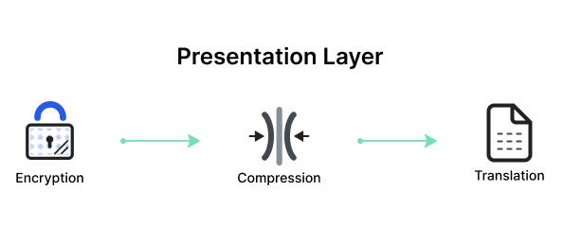

The Presentation Layer, also known as the syntax layer, is responsible for translating data between the application layer and the network format. It ensures that data sent from the application layer of one system is readable by the application layer of another system. This layer handles data formatting, [encryption](https://www.imperva.com/learn/data-security/data-encryption/), and compression, facilitating interoperability between different systems.

One of the key roles of the Presentation Layer is data translation and code conversion. It transforms data into a format that the application layer can understand. For example, it may convert data from ASCII to EBCDIC. It also includes encryption protocols to ensure [data security](https://www.imperva.com/learn/data-security/data-security/) during transmission and compression protocols to reduce the amount of data for efficient transmission.

### **7. Application Layer**

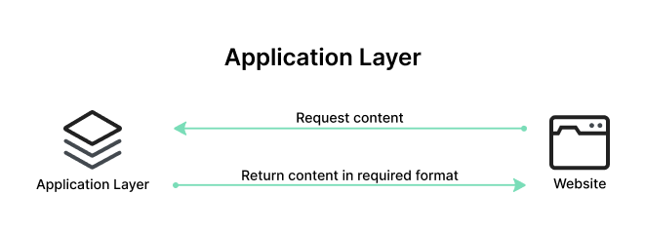

The Application Layer serves as the interface between the end-user applications and the underlying network services. This layer provides protocols and services that are directly utilized by end-user applications to communicate across the network. Key functionalities of the Application Layer include resource sharing, remote file access, and network management.

Examples of protocols operating at the Application Layer include [Hypertext Transfer Protocol (HTTP)](https://www.imperva.com/learn/performance/http2/) for web browsing, File Transfer Protocol (FTP) for file transfers, Simple Mail Transfer Protocol (SMTP) for email services, and Domain Name System (DNS) for resolving domain names to IP addresses. These protocols ensure that user applications can effectively communicate with each other and with servers over a network.

**Task 11:**

**What is an IPv4 address? What are the different classes of IPv4?**

**IPV4:**

IPv4, or Internet Protocol version 4, is a protocol that assigns unique numerical addresses (32-bit) to devices on a network, enabling them to communicate with each other across the internet. These addresses are typically written in a dotted decimal format (e.g., 192.168.1.1).

**Classes of IPv4:**

IPv4 addresses are classified into five classes (A, B, C, D, and E) based on the first octet of the address. These classes were designed to accommodate different network sizes and address the different needs of various networks.

Here's a more detailed explanation of each class:

* Class A: The first octet ranges from 0 to 127, typically used for large networks.
* Class B: The first octet ranges from 128 to 191, designed for medium-sized networks.
* Class C: The first octet ranges from 192 to 223, used for smaller networks.
* Class D: The first octet ranges from 224 to 239, reserved for multicast addressing, allowing a single packet to be sent to multiple devices simultaneously.
* Class E: The first octet ranges from 240 to 255, reserved for experimental purposes and future use.

**Task 12:**

**What are the advantages of using VPN?**

Using a VPN offers several advantages, primarily focused on privacy, security, and access to restricted content. It encrypts your internet traffic, masks your IP address, and can bypass geo-restrictions, all while enhancing your online safety and freedom.

Here's a more detailed look at the benefits:

Privacy and Security:

* Masking IP Address:  
   VPNs hide your actual IP address, making it harder for websites and online trackers to follow your browsing activity.
* Encrypting Internet Traffic:  
   This ensures that your data is scrambled and protected from eavesdropping, even on public Wi-Fi networks.
* Secure Public Wi-Fi:  
   VPNs create a secure tunnel, protecting your data on potentially insecure public networks.
* Protecting Against Throttling:  
   VPNs can help prevent your internet service provider (ISP) from slowing down your connection or restricting certain types of traffic.
* Bypassing Restrictions and Accessing Content:
* Geo-Restricted Content:  
   VPNs can bypass regional restrictions, allowing you to access streaming services, websites, and other content that may be blocked in your location.
* Avoiding Censorship:  
   In countries with limited internet freedom, VPNs can help you access blocked websites and services.
* Other Benefits:
* Remote Access:  
   VPNs enable secure and private connections to your home network or company network from anywhere with an internet connection.
* Enhanced Productivity:  
   For businesses, VPNs allow employees to work remotely securely, maintaining productivity and confidentiality.
* Potential Cost Savings:  
   VPNs can reduce the need for expensive leased lines and long-distance phone calls.

**Task 13:**

Types of VPN

Give 1 liner for each

* **Access VPN:** Enables remote users to securely connect to an organization's network.
* **Site-to-Site VPN:** Establishes secure connections between two or more geographically separate locations.
* **Intranet VPN:** A site-to-site VPN within an organization, connecting different locations of the same company.
* **Extranet VPN:** A site-to-site VPN that connects different organizations, like a company and its partners, over a shared network.

**Task 14:**

**Node and link:**

Node is a computer/any device/server

Link is the connection between them

**Task 15:**

**Topology means:** Network topology refers to the arrangement of devices and their connections within a computer network. It can be classified into physical and logical topologies, with the former describing the physical layout of cables and devices, and the latter defining how data flows within the network. Common types of network topology include bus, star, ring, mesh, and tree

**Task 16:**

**Different types of network topology:**

Main types: Physical and Logical

Physical Topology:

* **Bus:** All devices connect to a single shared cable or backbone.
* **Star:** Each device connects to a central hub or switch.
* **Ring:** Each device connects to two other devices, forming a loop.
* **Mesh:** Each device connects to every other device, providing redundancy.
* **Tree:** A hierarchical structure with a central root node and branching connections.
* **Hybrid:** Combines two or more of the above topologies

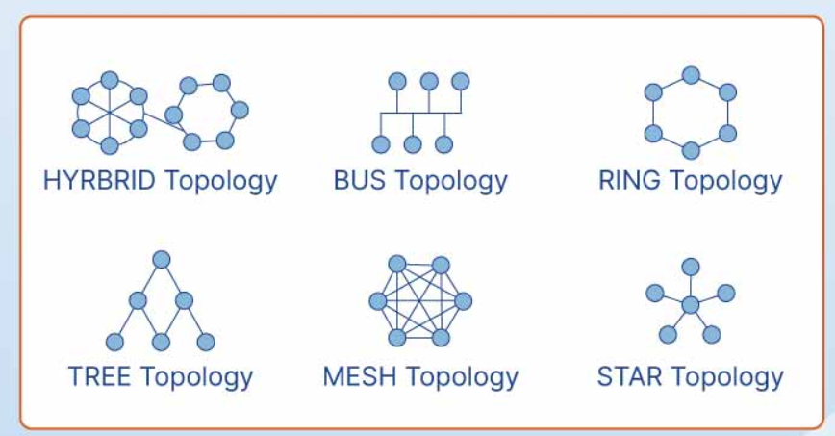

**Task 17:**

Extended bus topology is tree topology

**Task 18:**

**What is the use of a router and how is it different from a gateway?**

A router and a gateway are both network devices that facilitate communication between different parts of a network, but they have distinct roles. A router primarily handles data within similar networks, choosing the best path for data packets to travel. A gateway, on the other hand, connects dissimilar networks, often acting as a bridge between different protocols or formats

**Router Example:**

A home Wi-Fi router connected to your modem can be seen as a router, as it directs data between your devices and the internet.

**Gateway example:**

A gateway might be used to connect a company's internal network (with one set of protocols) to the internet (using another set of protocols).

**Task 19:**

**SMTP:** Simple Mail transfer Protocol (Only for sending)

IMAP:

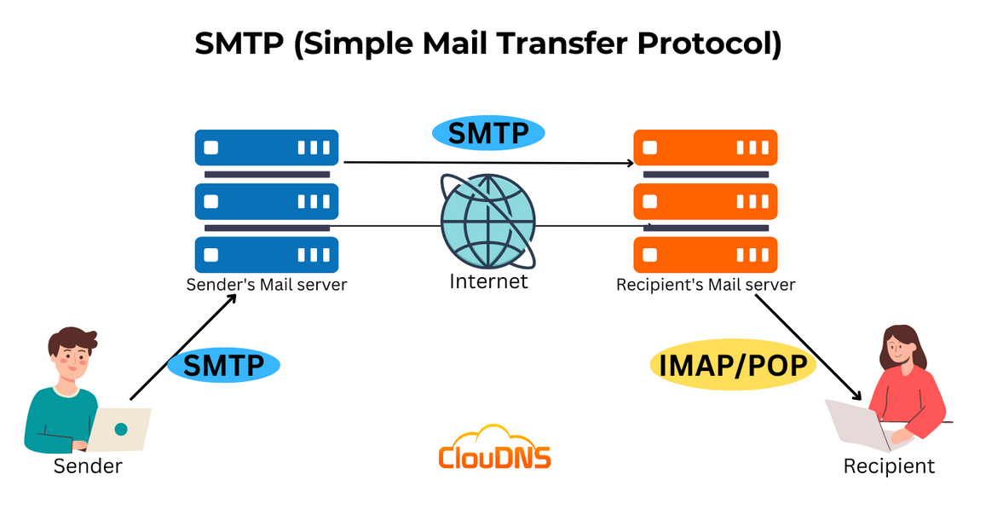

**Task 20:**

Difference between OSI and TCP/IP:

## **OSI Model**

[OSI](https://www.geeksforgeeks.org/layers-of-osi-model/) stands for Open Systems Interconnection. It has 7 layers [Physical layer](https://www.geeksforgeeks.org/physical-layer-in-osi-model/), [Data Link layer](https://www.geeksforgeeks.org/data-link-layer/), [Network layer](https://www.geeksforgeeks.org/network-layer-in-osi-model/), [Transport layer](https://www.geeksforgeeks.org/transport-layer-in-osi-model/), [Session layer](https://www.geeksforgeeks.org/session-layer-in-osi-model/), [Presentation layer](https://www.geeksforgeeks.org/presentation-layer-in-osi-model/), and [Application layer](https://www.geeksforgeeks.org/application-layer-in-osi-model/). Each layer performs its task independently. It was developed in 1984 by the International Organization for Standardization (ISO).

| **Parameters** | **OSI Model** | **TCP/IP Model** |
| --- | --- | --- |
| **Full Form** | OSI stands for Open Systems Interconnection | TCP/IP stands for Transmission Control Protocol/Internet Protocol |
| **Layers** | It has 7 layers | It has 4 layers |
| **Usage** | It is low in usage | It is mostly used |
| **Approach** | It is vertically approached | It is horizontally approached |
| **Delivery** | Delivery of the package is guaranteed in OSI Model | Delivery of the package is not guaranteed in TCP/IP Model |
| **Replacement** | Replacement of tools and changes can easily be done in this model | Replacing the tools is not easy as it is in OSI Model |
| **Reliability** | It is less reliable than TCP/IP Model | It is more reliable than OSI Model |
| **Protocol Example** | Not tied to specific protocols, but examples include HTTP (Application), SSL/TLS (Presentation), TCP (Transport), IP (Network), Ethernet (Data Link) | HTTP, FTP, TCP, UDP, IP, Ethernet |
| **Error Handling** | Built into Data Link and Transport layers | Built into protocols like TCP |
| **Connection Orientation** | Both connection-oriented (TCP) and connectionless (UDP) protocols are covered at the Transport layer | TCP (connection-oriented), UDP (connectionless) |

**Task 21:**

**HTTP vs HTTPS:**

HTTP: Hyper text Transfer Protocol uses port 80, less secure, not encrypted.

HTTPS: Secure Hyper Text Transfer Protocol uses port 443, secured, encrypted.

**Task 22:**

**What is HLD and LLD:**

In SDLC, High-Level Design (HLD) provides an overview of the system architecture and major components, while Low-Level Design (LLD) focuses on the detailed implementation of individual modules and their interactions

**Task 23:**

**What is SRS (Software Requirement Specification):**

Software Requirement Specification is a crucial document that outlines the detailed requirements for a software product. It acts as a blueprint, ensuring that the software developed meets the needs of the users, business stakeholders and aligns with project goals. The SRS is used throughout the SDLC, serving as a reference point for different phases like design, development, and testing.

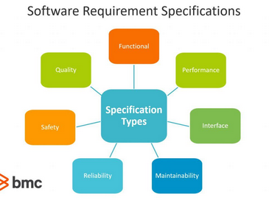

## **SDLC MCQ**

1. A feasibility study using the SDLC model is conducted to

determine whether or not the project is technically possible

determine whether the proposal is financially viable

Both a and b

None of the above

2.

A well-documented life cycle model aids in the detection of what during the development phase?

Inconsistencies

Redundancies

Omission

All of the above

3.

How many lines of code does the Build & Fix Model suit for programming exercises?

100-200

300-400

600-700

Above 800+

4.

In which life cycle does regression testing play a significant role?

Waterfall model

V model

Iterative model

All of the above

5.

What determines if the project should go forward?

feasibility assessment

opportunity identification

system evaluation

program specification

6.

What is the most significant disadvantage of employing the RAD Model?

Developers/designers that are highly specialized and skilled are required.

Component reusability is improved.

Encourages client/customer input.

Increases component reusability.

7.

Which of the following developmental models is incremental?

Prototyping, V model, Agile

Prototyping, RAD, Agile, RUP

Prototyping, V model, RAD, Agile, RUP

All of the above

8.

Which of the following is an Agile development characteristic?

Shared code ownership

Test-Driven Development

Implement the simplest solution to meet today's problem

Continual feedback from customer

All of the above

9.

Which of the following steps in the SDLC framework are valid?

Requirement Gathering

Software Design

System Analysis

All of the above

10.

Who is in charge of system development, staffing, budgeting, and reporting, as well as ensuring that deadlines are met?

Project managers

Network engineers

Graphic designers

Systems analysts